## Project Structure

**1. Database Setup**

* **Database Creation**: The project starts by creating a database named data_sales.
* **Table Creation**: A table named retail_sales is created to store the sales data. The table structure includes columns for transaction ID, sale date, sale time, customer ID, gender, age, product category, quantity sold, price per unit, cost of goods sold (COGS), and total sale amount.

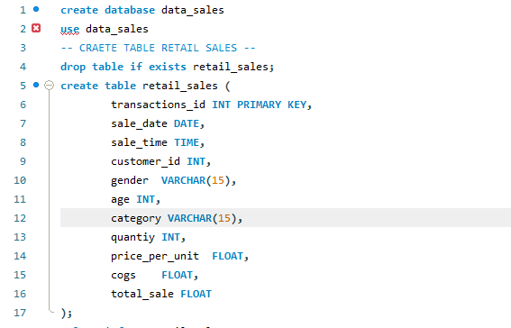

**2. Data Exploration & Cleaning**

* **Record Count**: Determine the total number of records in the dataset.
* **Customer Count**: Find out how many unique customers are in the dataset.
* **Category Count**: Identify all unique product categories in the dataset.
* **Null Value Check**: Check for any null values in the dataset and delete records with missing data.

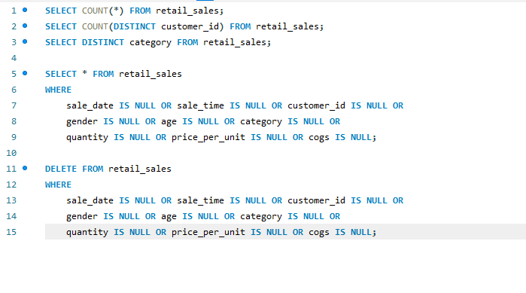

### 3. Data Analysis & Findings

The following SQL queries were developed to answer specific business questions:

1. **How many sales we have?**

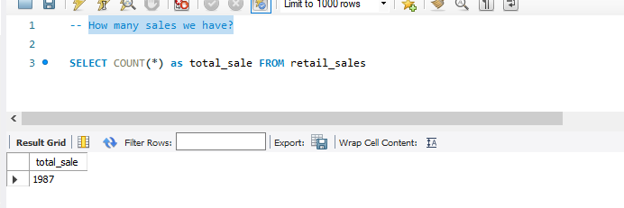

1. **How many unique customers we have ?**

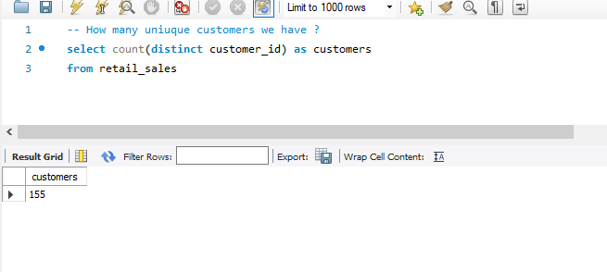

1. **Write a SQL query to retrieve all columns for sales made on '2022-11-05:**

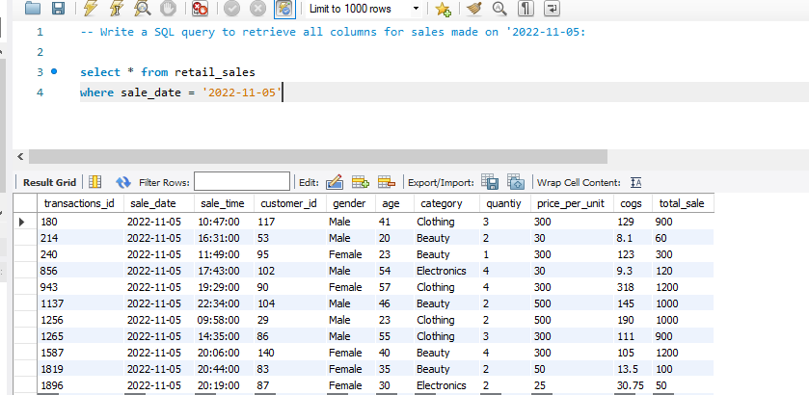

1. **Write a SQL query to retrieve all transactions where the category is 'Clothing' and the quantity sold is more than 4 in the month of Nov-2022:**

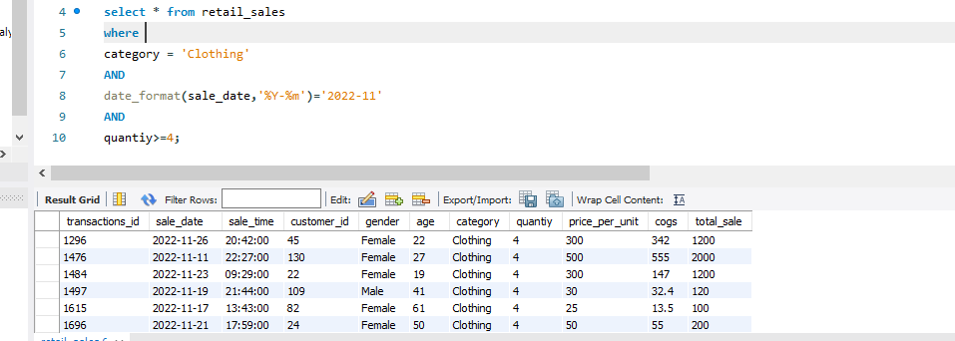

1. **Write a SQL query to calculate the total sales (total_sale) for each category.:**

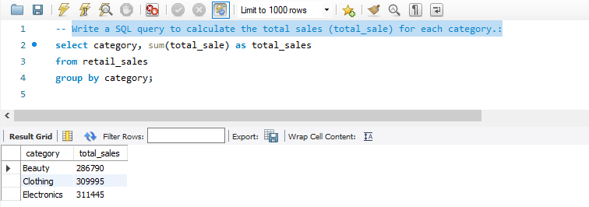

1. **Write a SQL query to find the average age of customers who purchased items from the 'Beauty' category.:**

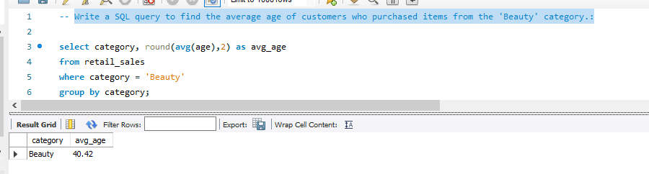

1. **Write a SQL query to find all transactions where the total_sale is greater than 1000. also find the count of transation:**

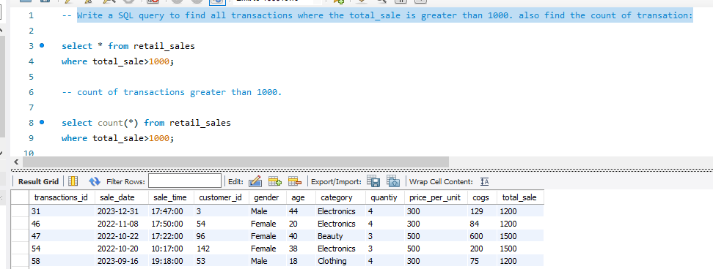

1. **Write a SQL query to find the total number of transactions (transaction_id) made by each gender in each category.:**

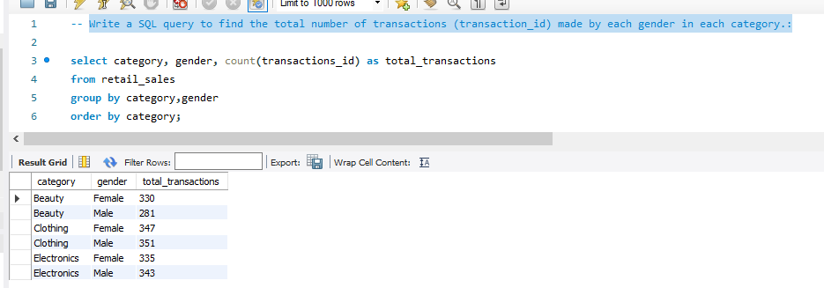

1. **Write a SQL query to find the top 5 customers based on the highest total sales**

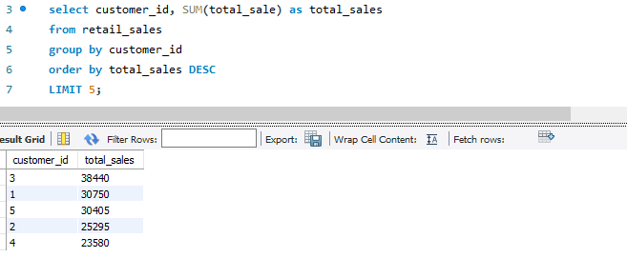

1. **Write a SQL query to calculate the average sale for each month.**

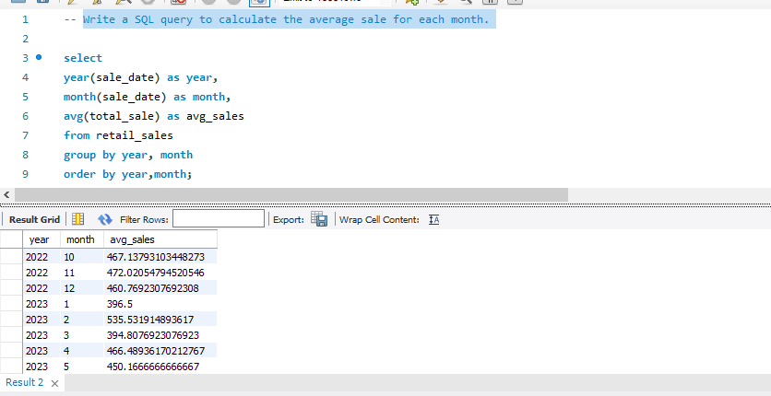

1. **Write a SQL query to calculate the average sale for each month. Find out best selling month in each year**:

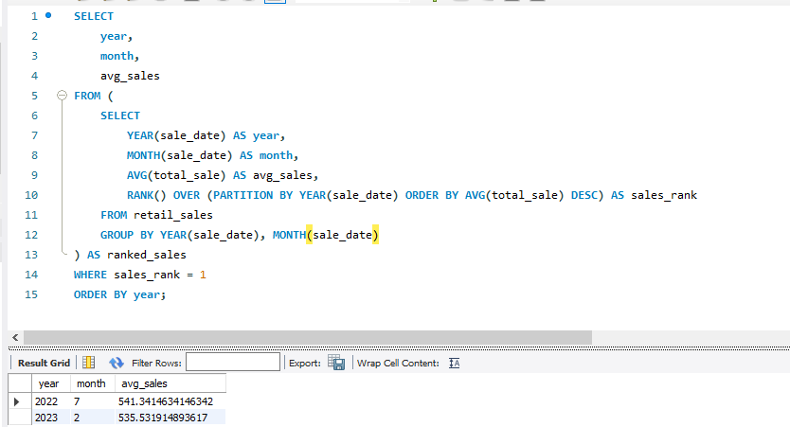

1. **Write a SQL query to find the number of unique customers who purchased items from each category.:**

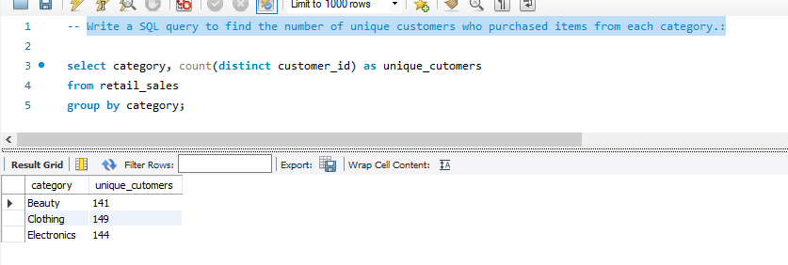

## Conclusion

This project serves as a comprehensive introduction to SQL for data analysts, covering database setup, data cleaning, exploratory data analysis, and business-driven SQL queries. The findings from this project can help drive business decisions by understanding sales patterns, customer behavior, and product performance.